SOFTWARE REQUIREMENTS SPECIFICATION DOCUMENT
© Axon Guidance
CSc 190 Senior Project
Department of Computer Science - College of Engineering and Computer Science
California State University, Sacramento
Version 5.4.2009

1. INTRODUCTION

This is the Software Requirements Specification document for the RFID Triangulation and Inventory project sponsored by the NAND Solutions Group of Intel.

This project is being undertaken by Axon Guidance development team. The team is comprised of undergraduate students majoring in Computer Science at California State University, Sacramento. The team members are enrolled in a two-semester senior project course required of all undergraduate majors. Successful delivery of the desired software product will fulfill the senior project requirement for the student team members.

The identification of the project sponsor and the team are as follows:

PROJECT SPONSORS:

Svanhild Simonson
Validation Engineer
svanhild.m.simonson@intel.com

Ronald Peroni
Validation Manager
ronald.j.peroni@intel.com

AXON GUIDANCE DEVELOPMENT TEAM:

Team Lead:
Steven Salmons
408.881.3310
stevefett@gmail.com

Team Members:
Salil Nizar
Forrest Slater
Morgan Darke

  - PURPOSE

The Software Requirements Specification defines the essential general and specific requirements of the product. The general requirements depict the product features and user interaction as well as any constraints and assumption that may affect the design of the product. The specific requirements provide the low-level technical detail and data required to support the high-level features.

  - SCOPE

This document only illustrates the high and low-level requirements of the product. It is only about requirements; it does not contain any information about the design phases or the managerial process of the product.

  - DEFINITIONS AND ACRONYMS

    - DEFINITIONS

Baseline: A baseline is a work product that has been formally reviewed and accepted by the involved parties. A baseline is changed only through formal configuration management procedures.

Software Requirements Specification: Documentation of the essential requirements (functions/features/uses, performance, design constraints, and attributes) of the software and its external interfaces.

Non-functional Requirements: A requirement that specifies criteria that can be used to judge the operation of a system, rather than specific behavior

Project Sponsor: The customer. Due to the academic nature of this project, the sponsor has no financial responsibilities for the development of the product.

1.3.2. ACRONYMS

RFID: Radio Frequency Identification. Small antenna tags with memory storage containing identification information
PHP: PHP Hypertext Preprocessor. Web-based language to be used in the user interface.
SQL: Structured Query Language. A relational database system to be used in the project.
SSD: Solid State Drive, in this case NAND based hard disks.
OLE: Object Linking and Embedding, a Microsoft-specific method of distributing objects.

  - OVERVIEW OF DOCUMENT CONTENTS

Section 2: General Description – The general requirements pertaining to how the product behaves.
Section 2.1: Project Perspective – Describes how the software being developed fits into other products or systems within the sponsors environment.
Section 2.2: Use Case Model of the system’s features – A model of the systems behavior as it interacts with outside entities.
Section 2.3: User Characteristics – The operational context of the software from the users ' perspective
Section 2.4: General Constraints – Any additional constraints that will limit the teams options in
designing the software.
Section 2.5: Assumption and Dependencies – Identifies all assumption and dependencies that
the development team expects to affect the software’s requirements.

Section 3: Specific Requirements – Contains all of the technical information and data needed to
design the software.
Section 3.1: Use Case Specifications – Provides detailed documentation of all of the Use Cases.
Section 3.1.1-3.1.12: Use Cases
Section 3.1.13: Information Model – Specifies the database to be developed as a part of the system.
Section 3.2: Performance Requirements – Specifies the operation requirements placed on both
the software and the users of the software.
Section 3.3: Design Constraints – Specifies the design constraints that can be imposed by
standards and hardware limitations.
Section 3.4: Quality Attributes – Contains the non-functional requirements.
Section 3.4.1: Reliability – Specifies the ability of the system to perform its required functions
under the stated conditions for a specified period of time.
Section 3.4.2: Maintainability – Specifies the ease of which the software can be modified.
Section 3.4.3: Program Quality Attributes – The quality of certain measurable attributes of a
program within the software.
Section 3.4.4: Security – The requirements for securing the system against threats to
confidentiality, integrity, and availability.
Section 3.4.5: Transferability/Conversion – Requirements specifying the ease of moving the
software from one platform to another.
Section 3.4.6: Operational Quality Attributes – The quality attributes pertaining to certain
aspects of the system.
Section 3.4.7: Operations – The specifications of what might be considered as normal and
special operations of the system.
Section 3.4.8: Site Adaptations – The specification of whatever system initialization
requirements are necessary.

Section 4: Approvals – The list of key signatories necessary to sign-off on the SRS.

Appendix A: Data Dictionary – A listing of all the data elements, data structures, and data tables representing the system.

2. GENERAL DESCRIPTION

2.1 PRODUCT PERSPECTIVE

This software is designed to track test products and equipment in a lab environment. The software requires a user to affix an RFID tag to any item that is to be tracked. The software interacts with an RFID transceiver through an API specified by the developer of the RFID transceiver hardware. This interaction is used to store item location information in a SQL database. This database will run on a server provided by the sponsor.
The end-user interface to the system will be accessible from a web-browser.

2.2 USE CASE MODEL

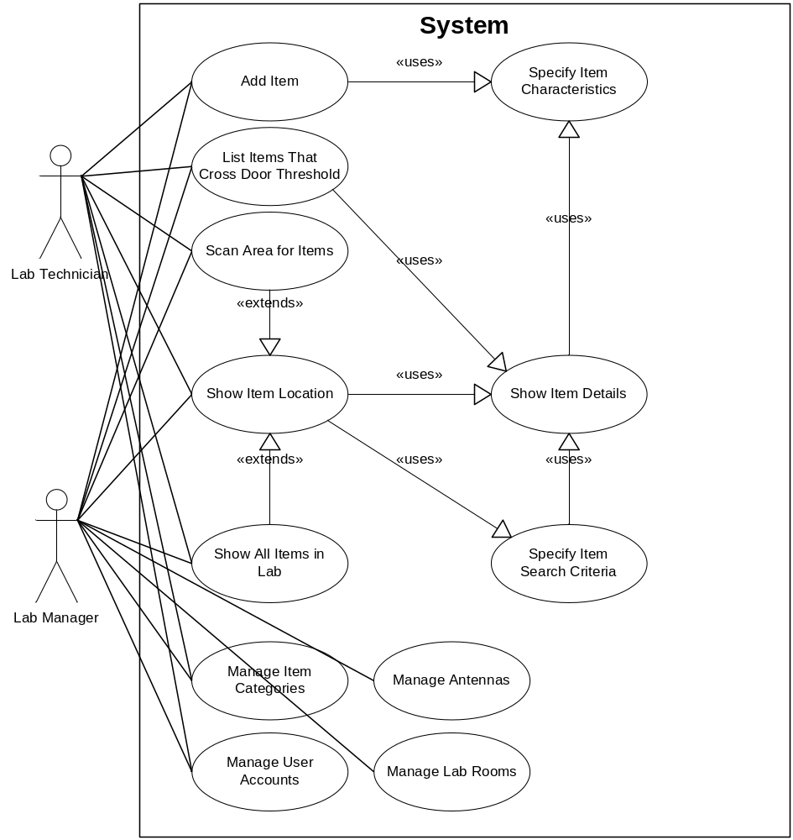

This section contains information that makes the specific requirements (found in the next section) easier to understand. The information provided describes the users and features that the product will provide. Since our system is designed to automate locating equipment in a lab environment, the use cases focus on retrieving an item’s location. Thus the fewer use cases that our system has, the simpler it is to use.

Use Case Name: Show Item Location
Actors: Lab Technician, Lab Manager
Description: The Actor specifies the items to locate. The system either looks up the last known location recorded in the database or performs a new scan on the RFID transceiver to locate the items. The system then displays the location to the actor.
Use Case Name: Specify Item Search Criteria
Actors: Lab Technician, Lab Manager
Description: The actor provides information about the items to locate. This information can be a serial number, tag ID number, item type (e.g. SSD, Test Equipment, Protocol Analyzer, Laptop, etc.), item description, target antenna(s), or keyword.
Use Case Name: Specify Item Characteristics
Actors: Lab Technician, Lab Manager
Description: The actor inputs the information about the item to add. This information can be a serial number, tag ID number, item type (e.g. SSD, Test Equipment, Protocol Analyzer, Laptop, etc.), item description, or keyword.
Use Case Name: Add Item
Actors: Lab Technician, Lab Manager
Description: The Actor inputs the characteristics of the item to add to the program and places an RFID tag on the write station. The system writes the serial number to the RFID tag. Then the actor sticks RFID tag to item.
Use Case Name: Show All Items in Lab
Actors: Lab Technician, Lab Manager
Description: The Actor requests to see all items currently in the lab. The system queries each antenna in the lab and displays a list of all items detected.
Use Case Name: Scan Area For Items
Actors: Lab Technician, Lab Manager
Description: Each specified antenna returns the tags that it detected.
Use Case Name: Show Item Details
Actors: Lab Manager
Description: This shows all fields for a specific item as stored in the database, as well as a history of the item's previous known locations and modifications to its characteristics.
Use Case Name: Manage Antennas
Actors: Lab Manager
Description: This use case allows the Lab Manager actor to add or update the antenna array in the case of addition, removal, or transfer of antenna nodes in the lab.
Use Case Name: Manage User Accounts
Actors: Lab Manager, Lab Technician
Description: This feature allows the Lab Manager actor to add, delete, or modify the user accounts for the software system.
Use Case Name: Manage Item Categories
Actors: Lab Manager, Lab Technician
Description: The lab manager is able to add, modify, or remove an Item Category. Examples include “hard drive,” “protocol analyzer,” or any other type of item classifications that items can be divided into.
Use Case Name: Manage Lab Rooms
Actors: Lab Manager
Description: Lab rooms will be added, deleted, or edited via this feature. Critical elements about the room, such as a room name and description, length and width dimensions in meters (of the largest lengths and widths for non-rectangular rooms), and a floorplan image of each room are kept here.
Use Case Name: List Items that Cross Door Threshold
Actors: Lab Technician, Lab Manager
Description: The user specifies a date or series of dates that ask the system to check for any items that have entered or left the lab on the specified dates. To detect if an item has left the lab, 3 scan histories will be used: A previous scan that shows the item was in the room, a previous scan showing the item picked up near the door antenna, and a scan showing the item no longer in the room. The opposite sequence of scans will determine if the item has entered the room.

2.3 USER CHARACTERISTICS

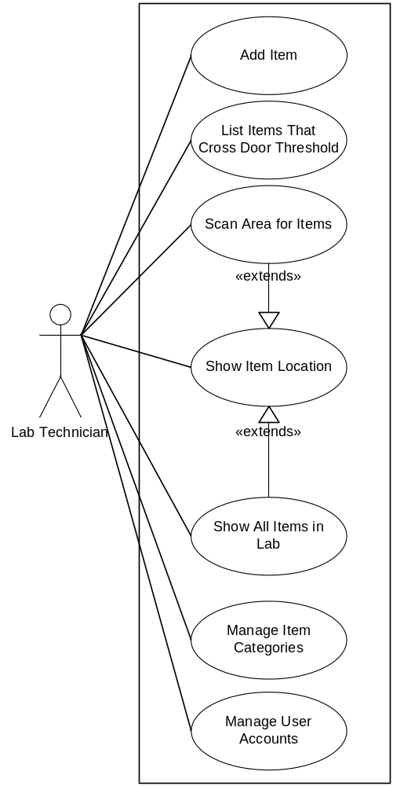

Lab Technician – The Lab Technician is responsible for running tests on equipment using various tools. The system assists Lab Technicians by tracking the location of all the tools and equipment in the lab, making it easy for a Lab Technician to find a specific tool or piece of equipment.
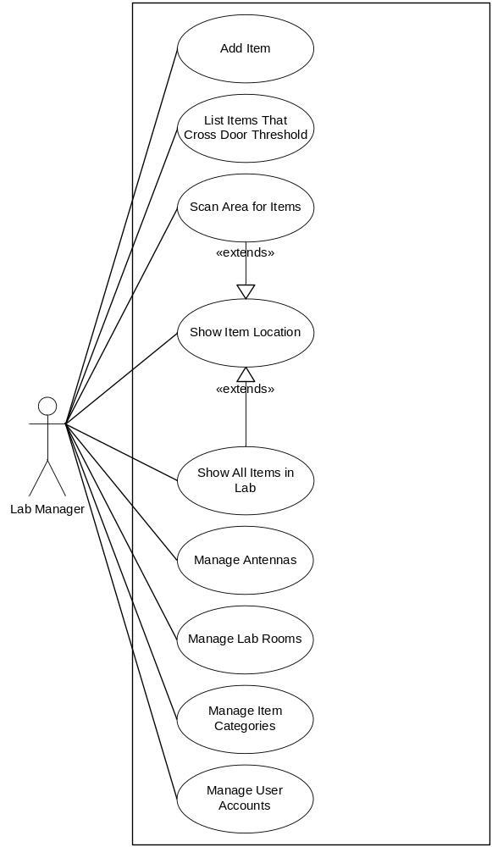
Lab Manager – The Lab Manger is responsible for all the equipment in the lab. The system provides functionality for the Lab Manager to keep track of the history of all items that have been in the lab.

2.4 GENERAL CONSTRAINTS
The following is a list of constraints on designing the system:
- The RFID tags must work at temperatures up to 60C.
- The algorithms for determining the location of an item are limited by the RFID transceiver’s specifications and API.
- The RFID transceiver and end-user interface must connect with Microsoft SQL Server.
- The installation and use of the RFID transceiver and antennas must conform to FCC specifications.
- The system must maintain a history of the location of each item.
- Access to the system must be limited to users on the Intel network.

2.5 ASSUMPTIONS AND DEPENDENCIES
The following is a list of assumptions and dependencies:
- The product will be designed around the current Intel networking and database environment, with no anticipation that the environment will change during the course of the project.
- The software will be designed with an emphasis on the least amount of administrative overhead or maintenance required.
3. SPECIFIC REQUIREMENTS

3.1 USE CASE SPECIFICATI1ONS

3.1.1 USE CASE: SHOW ITEM LOCATION

Use Case ID: | UC-1 | Use Case Name: | Show Item Location
Created By: | Steven Salmons | Last Updated By: | Salil Nizar
Date Created: | 4/28/2009 | Date Last Updated: | 5/1/2009
Actors: | Lab Technician, Lab Manager
Description: | The Actor specifies the items to locate. The system either looks up the last known location recorded in the database or performs a new scan on the RFID transceiver to locate the items. The system then displays the location to the actor.
Preconditions: | 1. The User's identity has been authenticated.  2. The User is authorized to locate an item.  3. The tag database is online.  4. The RFID hardware is operational.  5. Search criteria has been entered.
Postconditions: | 1. The request is stored in the query log.
Normal Course: | 1.0 Locate an item in the Validation Laboratory  1. System lists database entries that match search criteria.  2. System asks user to locate via last stored location or run new  location scan.  3. System displays last stored location on the map (Alternative Course  1.1)  4. System displays newly scanned location on map (Alternative Course  1.2)
Alternative Courses: | 1.1 Display Last Stored Location (branch after step 2)  1. Location of last stored scan is used to draw location of item.  2. User is asked to exit or search for new criteria.  1.2 Display Current Location (branch after step 2)  1. New scan of the room is performed by the hardware.  2. Currently triangulated location is used to draw location of item.  3. User is asked to exit or search for new criteria.
Exceptions: | 1.E.1 Search Criteria Not Found (at step 1)  1. System displays message: " No matching items found."  2. System asks User whether they wish to search for another term.  3a. User asks to request another item.  4a. System starts Normal Course over.  3b. User asks to exit.  4b. System terminates the use case.
Includes: | UC-2 Specify Item Search Criteria
Priority: | High
Frequency of Use: | This use case, along with UC-2, will be the most used feature. Expected use is 50-75 times per week.
Business Rules:
DB Requirements: | AntennaTable  AntennaID  AntennaX  AntennaY  LocationTable  LocationID  PowerFound  FoundBy  ScanTime  TagID  RoomTable  RoomID  RoomDimensions  RoomGraphic  Relationships  Items found at Location  Location is in Room  Antenna finds Location  Room contains Antenna
Special Requirements: | 1. Any keywords essential for locating the object has been stored in the database by the user that entered it into the system.
Assumptions: | 1. The information stored in the database for each antenna and triangulatable item is correct and accurate.  2. All items are allowed to be "triangulated."
Notes and Issues:

3.1.2 USE CASE: Specify Item Search Criteria

Use Case ID: | UC-2 | Use Case Name: | Specify Item Search Criteria
Created By: | Steven Salmons | Last Updated By: | Salil Nizar
Date Created: | 4/28/2009 | Date Last Updated: | 5/1/2009
Actors: | Lab Technician, Lab Manager
Description: | The actor provides information about the items to locate. This information can be a serial number, tag ID number, item type (e.g. SSD, Test Equipment, Protocol Analyzer, Laptop, etc.), item description, target antenna(s), or keyword.
Preconditions: | 1. The User's identity has been authenticated.  2. The User is authorized to specify an item's search criteria.  3. The tag database is online.  4. Search criteria has been entered.  5. The user knows one of the searchable criteria for the desired item.
Postconditions: | 1. The request is stored in the query log.
Normal Course: | 1.0 Item Characteristics are entered as search criteria.  1. The User Interface displays fields used to enter the search criteria.  2. Fields will include Item Serial Number, Tag ID Number, Item Make  and/or Item Model Number, Keywords, Item Type, Antennas  3. Criteria is entered in one or more fields by User.  4. Submitted criteria is validated, ensuring only valid characters are  entered depending on the field.  5. Item Database is queried for all entered search criteria or wildcards.  6. Matching item(s) is(are) returned with links to full database listings  and triangulated position.  7. User clicks on full listing of desired item (Alternative Course 1).  8. User clicks on Triangulate Position (Alternative Course 2).
Alternative Courses: | 1.1 See Item Information and History (branch after step 6)  1. User is sent to Use Case UC-7  2. User is asked to exit or return to previous page.  1.2 Triangulate Location (branch after step 6)  1. User is sent to Use Case UC-1
Exceptions: | 1.0.E.1 Invalid Criteria Entered (at step 4)  1. System displays message: "The search criteria you have specified is  invalid."  2. System informs user of which field(s) was(were) invalid, and  highlights correct criteria format.  3a. User corrects incorrect field.  4a. System starts Normal Course over.  3b. User asks to exit.  4b. System terminates the use case.
Includes: | UC-1 Show Item Location  UC-7 Show Item Details
Priority: | High
Frequency of Use: | This use case, along with UC-1, will be the most used feature. Expected use is 50-75 times per week.
Business Rules:
DB Requirements: | ItemTable  TagID  SerialNumber  ItemMake  ItemModel  ItemClassID  ItemClassName  KeywordList  AddedBy  CurrentOwner  RoomTable  RoomID  AntennaTable  AntennaID  AntennaName  Relationships  User owns Item  User adds Item  Item is a ItemClass  Room contains Antenna
Special Requirements: | 1. Any keywords essential for locating the object has been stored in the database by the user that entered it into the system.
Assumptions: | 1. The information stored in the database for each antenna and triangulatable item is correct and accurate.  2. All items are allowed to be "triangulated."  3. Multiple items can match search criteria and must be listed.
Notes and Issues: | Can users select multiple items at once to be triangulated?

3.1.3 USE CASE: Specify Item Characteristics

Use Case ID: | UC-3 | Use Case Name: | Specify Item Characteristics
Created By: | Steven Salmons | Last Updated By: | Salil Nizar
Date Created: | 4/28/2009 | Date Last Updated: | 5/1/2009
Actors: | Lab Technician, Lab Manager
Description: | The actor inputs the information about the item to add. This information can be a serial number, tag ID number, item type (e.g. SSD, Test Equipment, Protocol Analyzer, Laptop, etc.), item description, or keyword.
Preconditions: | 1. The User's identity has been authenticated.  2. The User is authorized to add to an item's characteristics.  3. The tag database is online.  4. Search criteria has been entered and has been verified.  5. The appropriate item's record has been selected.
Postconditions: | 1. The request is stored in the query log.
Normal Course: | 1.0 Item Characteristics added/modified/updated.  1. The User Interface displays text fields, to be filled with current  stored information for each field from the database.  2. If User is authorized to deprecate item, the User Interface displays  option to deprecate item. (Alternative Course 1.1).  3. User enters any new or updated information into the appropriate  field.  4. User submits the updated information.  5. Submitted changes are validated, ensuring only valid characters are  entered depending on the field.  6. User is asked if they are sure they would like to update item's  record.  7. System moves previous values into item history and makes  requested changes.  8. User is returned to UC-7, showing new updates.
Alternative Courses: | 1.1 Deprecate Item Selected  1. User is asked if they are sure they would like to deprecate item.  2. System deprecates item.  3. User is sent to referring use case.
Exceptions: | 1.0.E.1 Invalid Data Entered (at step 5)  1. System displays message: "The information you have entered is  invalid."  2. System informs user of which field(s) was(were) invalid, and  highlights correct criteria format.  3a. User corrects incorrect field.  4a. System starts Normal Course over.  3b. User asks to exit.  4b. System terminates the use case.
Includes: | UC-7 Show Item Details  UC-4 Add Item
Priority: | Medium
Frequency of Use: | Occasional -- most frequent use will be after registering a new tag (UC-4) or upon assignment to/from new owner.
Business Rules:
DB Requirements: | ItemTable  TagID  SerialNumber  ItemMake  ItemModel  ItemClassID  ItemClassName  ItemClassDescription  KeywordList  AddedBy  DateAdded  ModifiedBy  DateModified  CurrentOwner  Relationships  User owns Item  User modifies Item  User adds Item
Special Requirements: | 1. Any keywords essential for locating the object has been stored in the  database by the user that entered it into the system.
Assumptions: | 1. The information stored in the database for each antenna and  triangulatable item is correct and accurate.
Notes and Issues: | 1. Should all users be able to edit all items? Owner only?

3.1.4 USE CASE: Add item

Use Case ID: | UC-4 | Use Case Name: | Add Item
Created By: | Steven Salmons | Last Updated By: | Salil Nizar
Date Created: | 4/28/2009 | Date Last Updated: | 5/1/2009
Actors: | Lab Technician, Lab Manager
Description: | The Actor inputs the characteristics of the item to add to the program and places an RFID tag on the write station. The system writes the serial number to the RFID tag. Then the actor sticks RFID tag to item.
Preconditions: | 1. The User's identity has been authenticated.  2. The User is authorized to add an item.  3. The tag database is online.  4. A tag has been placed on the tag writing station.  5. The tag is in good working condition.
Postconditions: | 1. The tag is securely attached to the item.
Normal Course: | 1.0 Item Added to the Tracking System.  1. The User places an RFID tag on the write station antenna.  2. User clicks on the "Add Item" interface option.  3. User enters product's serial number and type.  4. System generates unique tag identification number.  5. User submits add request.  6. User is asked to verify request.  7. Antenna writes tag identification information to tag.  8. User is asked to attach tag to product.  9. System sends user to UC-3 to specify further information.
Alternative Courses:
Exceptions: | 1.0.E.1 No Tag Found (at step 7)  1. System displays message: "No tag found in write range of antenna."  2. User is asked to put a tag on or near the write antenna and try  again.  1.0.E.2 Multiple Tags Found (at step 7)  1. System displays message: "Multiple tags found within write range."  2. User is asked to remove extra tags from write area and resubmit.
Includes: | UC-3 Specify Item Characteristics
Priority: | High
Frequency of Use: | Occasional -- Used whenever a new item is being added to the tracking system. Upon initial implementation of the system, use will be very high.
Business Rules:
DB Requirements: | ItemTable  TagID  SerialNumber  ItemClassID  ItemClassName  AddedBy  DateAdded  Relationships  User adds Item
Special Requirements: | 1. Tag IDs must be uniquely generated, using serial number as hash.
Assumptions: | 1. There will be only one tag per item.  2. No two items will have the same serial number.
Notes and Issues: | 1. Should multiple items having the same serial number be a concern?

3.1.5 USE CASE: Show All Items In Lab

Use Case ID: | UC-5 | Use Case Name: | Show All Items In Lab
Created By: | Steven Salmons | Last Updated By: | Salil Nizar
Date Created: | 4/28/2009 | Date Last Updated: | 5/4/2009
Actors: | Lab Technician, Lab Manager
Description: | The Actor requests to see all items currently in the lab. The system queries each antenna in the lab and displays a list of all items detected.
Preconditions: | 1. The User's identity has been authenticated.  2. The User is authorized to add an item.  3. The tag database is online.  4. The RFID hardware is online and operational.
Postconditions: | 1. The request is added to the transaction log.
Normal Course: | 1.0 All items currently in the lab are displayed.  1. User clicks on the "Show All Items In Lab" interface option.  2. System queries every antenna in the lab.  3. An inventory list of unique tag IDs found is displayed.  4. User can click on Show Item Details for a specific item (Alternative  Course 1.1)  5. User can click on Locate Item for a specific item (Alternative Course  1.2)
Alternative Courses: | 1.1 Show Item Details Selected (branch at step 4)  1. User is sent to UC-7.  1.2 Locate Item Selected (branch at step 5)  1. User is sent to UC-1.
Exceptions: | 1.0.E.1 No Items Found (at step 3)  1. System displays message: "No items found in lab."  2. User is returned to previous screen.
Includes: | UC-1 Show Item Location  UC-7 Show Item Details
Priority: | Low
Frequency of Use: | Rare -- Main use is for inventorying the lab.
Business Rules:
DB Requirements: | AntennaTable  AntennaID  AntennaX  AntennaY  LocationTable  FoundBy  ScanTime  ItemTable  TagID  SerialNumber  ItemMake  ItemModel  KeywordList  ItemClassID  ItemClassName  CurrentOwner  Relationships  User owns Item  Item is a ItemClass  Item found at Location  Location is in Room  Antenna finds Location  Room contains Antenna
Special Requirements:
Assumptions:
Notes and Issues:

3.1.6 USE CASE: Scan Area For Items

Use Case ID: | UC-6 | Use Case Name: | Scan Area For Items
Created By: | Steven Salmons | Last Updated By: | Salil Nizar
Date Created: | 4/28/2009 | Date Last Updated: | 5/4/2009
Actors: | Lab Technician, Lab Manager
Description: | Each specified antenna returns the tags that it detected.
Preconditions: | 1. The User's identity has been authenticated.  2. The User is authorized to add an item.  3. The tag database is online.  4. The RFID hardware is online and operational.
Postconditions: | 1. The request is added to the transaction log.
Normal Course: | 1.0 All requested antennas respond with items in scan range.  1. User clicks on the "Scan Specific Area For Items" interface option.  2. User selects antennas that cover desired scan area.  3. An inventory list of unique tag IDs found by the specified antennas  is displayed.  4. User can click on Show Item Details for a specific item (Alternative  Course 1.1)  5. User can click on Locate Item for a specific item (Alternative Course  1.2)
Alternative Courses: | 1.1 Show Item Details Selected (branch at step 4)  1. User is sent to UC-7.  1.2 Locate Item Selected (branch at step 5)  1. User is sent to UC-1.
Exceptions: | 1.0.E.1 No Items Found (at step 3)  1. System displays message: "No items found in lab."  2. User is returned to previous screen.
Includes: | UC-1 Show Item Location  UC-7 Show Item Details
Priority: | Medium
Frequency of Use: | High -- Some specific areas of the lab are of particular interest to individuals assigned to monitor the inventory of those areas.
Business Rules:
DB Requirements: | AntennaTable  AntennaID  AntennaX  AntennaY  LocationTable  FoundBy  ScanTime  ItemTable  TagID  SerialNumber  ItemMake  ItemModel  KeywordList  ItemClassID  ItemClassName  CurrentOwner  Relationships  User owns Item  Item found at Location  Location is in Room  Antenna finds Location  Room contains Antenna
Special Requirements:
Assumptions:
Notes and Issues: | 1. Antenna overlap and scan radius will affect the granularity of these scans.

3.1.7 USE CASE: Show Item Details

Use Case ID: | UC-7 | Use Case Name: | Show Item Details
Created By: | Steven Salmons | Last Updated By: | Salil Nizar
Date Created: | 4/28/2009 | Date Last Updated: | 5/01/2009
Actors: | Lab Technician, Lab Manager
Description: | The User reaches this screen from UC-2, UC-3, UC-5, and UC-6. This shows all fields for a specific item as stored in the database, as well as a history of the item's previous known locations and modifications to its characteristics.
Preconditions: | 1. The User's identity has been authenticated.  2. The User is authorized to add an item.  3. The tag database is online.  4. The RFID hardware is online and operational.  5. The link that has brought the user to this use case is for a valid item.
Postconditions: | 1. The request is added to the transaction log.
Normal Course: | 1.0 Detailed item characteristics and history are displayed..  1. User clicks on the "Show Item Details" interface option.  2. All fields, history tables, and transaction logs for this item are listed.  3. Interface displays option to edit item characteristics. (Alternative  Course 1.1)  4. Interface displays option to locate currently displayed item.  (Alternative Course 1.2)  5. User can return to previous screen. (Alternative Course 1.3)
Alternative Courses: | 1.1 Edit Item Characteristics Selected (branch at step 3)  1. User is sent to UC-3.  1.2 Locate Item Selected (branch at step 4)  1. User is sent to UC-1.  1.3 Return to Previous Screen (branch at step 5)  1. User is sent to referring use case.
Exceptions: | 1.0.E.1 Item Link Invalid (at step 2)  1. System displays message: "Item not found."  2. User is returned to previous screen.
Includes: | UC-1 Show Item Location  UC-2 Specify Item Search Criteria  UC-3 Specify Item Characteristics  UC-5 Show All Items In Lab  UC-6 Scan Area For Items
Priority: | High
Frequency of Use: | High -- Nearly every use of the system will involve this use case.
Business Rules:
DB Requirements: | AntennaTable  AntennaID  AntennaX  AntennaY  LocationTable  LocationID  FoundBy  ScanTime  ItemTable  TagID  SerialNumber  ItemMake  ItemModel  KeywordList  ItemClassID  ItemClassName  CurrentOwner  Relationships  User owns Item  User modifies Item  User adds Item  Item is a ItemClass  Item found at Location  Antenna finds Location
Special Requirements:
Assumptions:
Notes and Issues:

3.1.8 USE CASE: Manage Antennas

Use Case ID: | UC-8 | Use Case Name: | Manage Antennas
Created By: | Steven Salmons | Last Updated By: | Salil Nizar
Date Created: | 4/28/2009 | Date Last Updated: | 5/4/2009
Actors: | Lab Manager
Description: | This use case allows the Lab Manager actor to add or update the antenna array in the case of addition, removal, or transfer of antenna nodes in the lab.
Preconditions: | 1. The User's identity has been authenticated.  2. The User is authorized to add, remove, or modify an antenna.  3. The tag database is online.  4. The RFID hardware is online and operational.
Postconditions: | 1. The request is added to the transaction log.
Normal Course: | 1.0 Antenna node management screen is shown  1. User clicks on the "Manage Antennas” interface option.  2. System displays any antennas already in the system, as well as  interface options for adding an antenna.  3. User clicks on an existing antenna record to edit or remove the  antenna. (Alternative Course 1.1)  4. User clicks on the “Add Antenna” option to add a new antenna.  (Alternative Course 1.2)  5. User can return to previous screen. (Alternative Course 1.3)
Alternative Courses: | 1.1 Edit Antenna Selected (branch at step 3)  1. User is asked to rename or delete the antenna or change its  coordinates.  1.2 Add Antenna Selected (branch at step 4)  1. User is asked to input new antenna name and positional  coordinates.  1.3 Return to Previous Screen (branch at step 5)  1. User is sent to referring use case.
Exceptions: | 1.0.E.1 Antenna Name Exists (at 1.1 step 1 and at 1.2 step 1)  1. System displays message: "Antenna Name Exists."  2. User is asked to modify the submitted antenna name.  1.0.E.2 Antenna Exists at Coordinates (at 1.1 step 1 and at 1.2 step 1)  1. System displays message: “Antenna already exists at the specified  coordinates.”  2. User is asked to verify and change the coordinates specified.
Includes:
Priority: | High
Frequency of Use: | Low – modification of the antenna array should be a very uncommon occurance.
Business Rules:
DB Requirements: | AntennaTable  AntennaID  AntennaX  AntennaY  AntennaName  RoomTable  RoomID  Relationships  Room contains Antenna
Special Requirements:
Assumptions:
Notes and Issues:

3.1.9 USE CASE: Manage User Accounts

Use Case ID: | UC-9 | Use Case Name: | Manage User Accounts
Created By: | Steven Salmons | Last Updated By: | Salil Nizar
Date Created: | 4/28/2009 | Date Last Updated: | 5/4/2009
Actors: | Lab Manager, Lab Technician
Description: | This feature allows the Lab Manager actor to add, delete, or modify the user accounts for the software system.
Preconditions: | 1. The User's identity has been authenticated.  2. The User is authorized to manage a user account.  3. The tag database is online.  4. The RFID hardware is online and operational.
Postconditions: | 1. The request is added to the transaction log.
Normal Course: | 1.0 A user account is added to the system.  1. User clicks on the "Add User" interface option. This option is only  available for lab managers.  2. System asks user for UserName, FirstName, LastName, temporary  password, and access level (guest, technician, manager)  3. System generates a unique user ID for the new account.  4. System adds new user to the User Table.  5. User is returned to user account listing.  2.0 A user account is modified.  1. User clicks on one of the listed user account names. For a lab  technician, only the user’s personal account will be listed.  2. System displays user table fields with existing values entered.  3. User enters new account information or resets password.  4. System updates account record.  5. User is returned to user account listing.
Alternative Courses:
Exceptions: | 1.0.E.1 Username already exists (at 1.0 step 2 and at 2.0 step 4)  1. System displays message: "Username Already Exists."  2. User is returned to previous screen to modify entered username.
Includes:
Priority: | High
Frequency of Use: | Low –Initial configuration will require the most use of this use case. Beyond that, only new technician hires will require this feature.
Business Rules:
DB Requirements: | UserTable  UserID  UserName  FirstName  LastName  Password  Permissions
Special Requirements: | 1. Password field values will be encrypted for security reasons.
Assumptions:
Notes and Issues:

3.1.10 USE CASE: Manage Item Categories

Use Case ID: | UC-10 | Use Case Name: | Manage Item Categories
Created By: | Steven Salmons | Last Updated By: | Salil Nizar
Date Created: | 4/28/2009 | Date Last Updated: | 5/4/2009
Actors: | Lab Manager, Lab Technician.
Description: | The lab manager is able to add, modify, or remove an Item Category. Examples include “hard drive,” “protocol analyzer,” or any other type of item classifications that items can be divided into.
Preconditions: | 1. The User's identity has been authenticated.  2. The User is authorized to manage item category.  3. The tag database is online.  4. The RFID hardware is online and operational.
Postconditions: | 1. The request is added to the transaction log.
Normal Course: | 1.0 Item Categories are edited, removed, or added.  1. User clicks on the "Manage Item Categories” interface option.  2. Current item category in the table are displayed for selection.  3. User selects an existing item category from the list. (Alternative  Course 1.1)  4. User chooses to add a new item category.  (Alternative Course 1.2)  5. User can return to previous screen. (Alternative Course 1.3)
Alternative Courses: | 1.1 Edit Item Category Selected  1. User is asked to edit or remove the Item Class Name or Item Class  Description.  2. Item class table is updated with the new information.  3. User is returned to the previous screen.  1.2 Add New Item Category  1. User is asked to specify a new item class and class description.  2. System generates a new unique class ID for the entered data.  3. Item class table is updated with the new record.  4. User is returned to previous screen.
Exceptions: | 1.0.E.1 Item Class Already Exists (at 1.1 step 2 and at 1.2 step 2)  1. System displays message: "Item Class Already Exists."  2. User is returned to previous screen to modify the item class name.
Includes:
Priority: | High
Frequency of Use: | Low – Most of the use of this case will be upon initial system configuration and launch.
Business Rules:
DB Requirements: | ItemClassTable  ItemClassID  ItemClassName  ItemClassDescription
Special Requirements: | 1. Item categories are selected by pull-down lists that allow only the categories defined in this table to be used to categorize an item.  2. All items must have a category specified.
Assumptions:
Notes and Issues: | 1. Should all users be able to specify an item category?  2. Should new item classes be addable when adding a new item to the system, in case a user needs to add a new category for the new item?

3.1.11 USE CASE: Manage Lab Rooms

Use Case ID: | UC-11 | Use Case Name: | Manage Lab Rooms
Created By: | Steven Salmons | Last Updated By: | Salil Nizar
Date Created: | 4/28/2009 | Date Last Updated: | 5/4/2009
Actors: | Lab Manager
Description: | Lab rooms will be added, deleted, or edited via this feature. Critical elements about the room, such as a room name and description, length and width dimensions in meters (of the largest lengths and widths for non-rectangular rooms), and a floorplan image of each room are kept here.
Preconditions: | 1. The User's identity has been authenticated.  2. The User is authorized to manage the lab room information.  3. The tag database is online.  4. The RFID hardware is online and operational.
Postconditions: | 1. The request is added to the transaction log.
Normal Course: | 1.0 Lab Room information is edited.  1. User clicks on one of the existing room named listed.  2. Currently configured room name, room description, room  dimensions, and room graphic are displayed along with options to  modify or delete them.  3. User specifies new information for desired fields.  4. System updates the room table with the new information  5. User is returned to the previous screen.  2.0 Lab Room is added.  1. User clicks on the add room interface option.  2. System displays room table fields for the user to fill out.  3. System adds new room information to the room table.  4. User is sent to the Manage Antennas screen for the room.
Alternative Courses:
Exceptions: | 1.0.E.1 Room Name Already Exists (at 1.0 step 4 and at 2.0 step 3)  1. System displays message: "Room Name Already Exists."  2. User is returned to previous screen to modify the room name.
Includes: | UC-8 Manage Antennas
Priority: | Low
Frequency of Use: | Rare – Currently, the software is meant to be utilized in a single lab environment, so this use case is for future expandability.
Business Rules:
DB Requirements: | RoomTable  RoomID  RoomName  RoomDescription  RoomXDimension  RoomYDimension  RoomGraphic
Special Requirements:
Assumptions:
Notes and Issues:

3.1.12 USE CASE: List Items that Cross Door Threshold

Use Case ID: | UC-12 | Use Case Name: | List Items That Cross Door Threshold
Created By: | Steven Salmons | Last Updated By: | Salil Nizar
Date Created: | 4/28/2009 | Date Last Updated: | 5/4/2009
Actors: | Lab Technician, Lab Manager
Description: | The user specifies a date or series of dates that ask the system to check for any items that have entered or left the lab on the specified dates. To detect if an item has left the lab, 3 scan histories will be used: A previous scan that shows the item was in the room, a previous scan showing the item picked up near the door antenna, and a scan showing the item no longer in the room. The opposite sequence of scans will determine if the item has entered the room.
Preconditions: | 1. The User's identity has been authenticated.  2. The User is authorized to add an item.  3. The tag database is online.  4. The RFID hardware is online and operational.
Postconditions: | 1. The request is added to the transaction log.
Normal Course: | 1.0 Items that have crossed the door threshold are displayed.  1. User enters one or more days to analyze for items leaving/entering  lab.  2. System utilizes item location histories to check for the series of  scans listed in the description.  3. Items and timestamps of their arrival/departure that fall within the  requested dates are listed.  4. User can click on an item to see its detailed characteristics and  location history. (UC-7)
Alternative Courses:
Exceptions:
Includes: | UC-7 Show Item Details
Priority: | Medium
Frequency of Use: | Low
Business Rules:
DB Requirements: | AntennaTable  AntennaID  AntennaX  AntennaY  LocationTable  LocationID  FoundBy  ScanTime  ItemTable  TagID  SerialNumber  ItemMake  ItemModel  KeywordList  ItemClassID  ItemClassName  CurrentOwner  Relationships  User owns Item  Item is a ItemClass  Item found at Location  Location is in Room  Antenna finds Location  Room contains Antenna
Special Requirements:
Assumptions:
Notes and Issues: | Can user also specify a range of dates?

3.1.13 INFORMATION MODEL

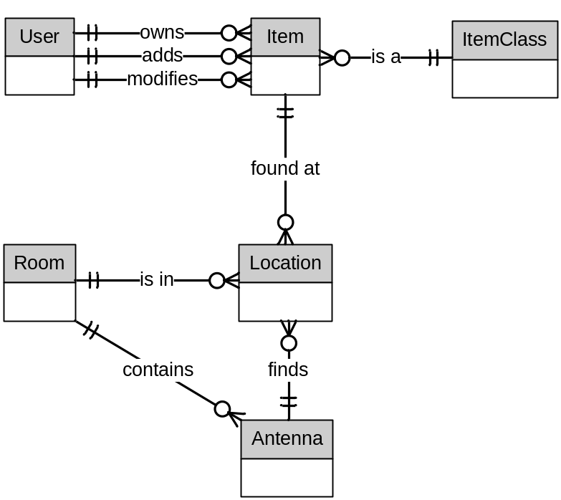

Relationship | Cardinality | Use Cases Supported
User owns Item | 1 User to many Item | Specify Item Search Criteria, Specify Item Characteristics, Show Item Details, Show all Items in Lab, Scan area for Items, List Items that Cross Door Threshold
User modifies Item | 1 User to many Item | Specify Item Search Criteria, Specify Item Characteristics, Show Item Details
User adds Item | 1 User to many Item | Specify Item Search Criteria, Specify Item Characteristics, Add Item, Show Item Details
Item is a ItemClass | 1 ItemClass to many Item | Specify Item Search Criteria, Specify Item Characteristics, Add Item, Show Item Details, Show all Items in Lab, List Items that Cross Door Threshold
Item found at Location | 1 Item to many Location | Show Item Location, Show all Items In Lab, Scan Area For Items, Show Item Details, List Items that Cross Door Threshold
Location is in Room | 1 Room to many Location | Show Item Location, Show all Items In Lab, Scan Area For Items, List Items that Cross Door Threshold
Antenna finds Location | 1 Antenna to many Location | Show Item Location, Show all Items In Lab, Scan Area For Items, List Items that Cross Door Threshold
Room contains Antenna | 1 Room to many Antenna | Show Item Location, Show all Items In Lab, Scan Area For Items, Manage Antennas, List Items that Cross Door Threshold, Specify Item Search Criteria

3.2 PERFORMANCE REQUIREMENTS

The system will be implemented in the following fixed performance environment:

- 1 Server -- To run the Web Server, SQL database, and the Transceiver-to-SQL driver.
- 50 simultaneous clients -- the approximate number of Validation Engineers that will be expected to use this system at peak times.
- 1000+ Data Stores -- Number of items to track and triangulate.
- 10 Records per Store -- Current information plus 9 histories.
- 1 Transceiver per 4 Antennae

The system will deal with the following variable (dynamic) performance requirements:

- A full inventory requiring approximately 200-300 tag reads per antenna.
- An antenna scan requiring approximately 5 seconds to complete for inventory scanning.
- A fresh triangulation scan taking approximately 1 minute to complete.

3.3 DESIGN CONSTRAINTS

The design will be built on its own subnet to the server to minimize broadcast traffic from the transceivers. It will also be designed to work in the laboratory's standard IT infrastructure (Windows Server IIS, Microsoft Enterprise SQL). While the database design, user interface, and identification tag structure is going to be vendor-nonspecific, the Transceiver to SQL driver will be specific to the ThingMagic brand RFID hardware. To use this system with another transceiver/antenna manufacturer would require a new driver to be designed. However, the user interface, database, and any algorithms contained therein will still function.

3.4 QUALITY ATTRIBUTES

3.4.1 RELIABILITY

The following mean time between failures is highlighted for each layer of the system:
- RFID Scanning Hardware: Current target scan timeframes are once every 5 seconds for inventory scans, which is based on the amount of time for a person to cross half the length of an antenna's field. Therefore, a mean failure rate of one failure every 10 seconds would be the worst case while maintaining location accuracy.
- Transceiver to SQL Driver: Failure at this level could mean data loss or corruption for a full scan. Any failures will prevent it from completing its required function, therefore there is no acceptable mean failure rate.
- User Interface Queries: Failures due to timeouts are acceptable approximately 5% of times used, as more timeouts beyond that would diminish user satisfaction.

3.4.2 MAINTAINABILITY

The multi-layered design of the software's roles will ensure a much quicker time-to-repair in the case of software failure. The driver will be the most difficult to maintain, as it will contain functions designed by the hardware manufacturer that have failure situations that are beyond the developer's control from which to recover. Interface features have been divided into specific use-case categories, outlined above, and any issues regarding the querying of the database would be limited to individual features. This encapsulation will also speed up repair times. Mean time of repair of reliability or performance faults would be 10-15 hours for the driver and 2-5 hours for the interface, including validation of implemented fixes.

3.4.3 PROGRAM QUALITY ATTRIBUTES

- Readability, Understandability, and Comprehensibility: To ensure that the logic, structure, and use of the software is clear and easy to understand, feature use will follow intuitive steps similar to most standard search engines such as Google. A search prompt of criteria fields, as well as preset search modes (Full Lab and Specific Areas of the Lab) will be presented. Upon successful search, the results will display much like the results of a Google search, with self explanatory links to follow for specific feature use.
- Robustness: To protect against bad data and misuse, form input will be validated both at the interface level and the database level. Only input that clears both of these hurdles will be stored in the database.
- Speed of Execution: Because of the complexity of the triangulation feature, quicker modes of scanning and inventorying are added to counter the more time intensive process of triangulating an object's position. This will allow users that simply want to verify an object's general location or take inventory of a specific area or item category to perform their use cases quickly. Triangulation, on the other hand, will require more wait-time for the user, measurable in minutes rather than seconds.

3.4.4 SECURITY

Due to the high quantity of physical protection at Intel's Folsom campus, unauthorized access from an internal level is the only potential physical security risk. A username/password authentication system will ensure that only members of the Validation Team that make use of the laboratory will be given access to the software.

As to data security and protection, redundancy is the only foolproof method to protect from accidental destruction or loss of data. A backup server, network accessible storage device, or local external storage device would be necessary to facilitate such a backup. However, due to the nature of the design of the database structure, only the core Tag Database would truly need to be stored for the system to remain operational -- upon recovery of the server, the initial scans would repopulate the tag locations automatically.

3.4.5 TRANSFERABILITY / CONVERSION

The SQL database and user interface designs will only require that the destination system for any platform transfer have a SQL server and PHP-capable web server daemons installed. The driver, however, will be written in C, and therefore will need recompiling due to potential architecture differences that may cause the executable to no longer function. While cross-OS compatibility is an optional goal of this design, we currently only plan to support transfers across Windows platforms.

3.4.6 OPERATIONAL QUALITY ATTRIBUTES

Due to the client's environment, the User Interface will be in English only. No ancillary help system will be designed, as the interface is completely web based -- however, any features that have uses that are not inherently clear will have some text to explain their proper use.

3.4.7 OPERATIONS

The following are a specification of the software's modes of operations.
- Administrative: Adding a product, user, room, item class, antenna to the system, modifying their characteristics.
- Normal: Querying a product's information, graphical location, location histories.

3.4.8 SITE ADAPTATIONS

To install and operate the software, the RFID hardware needs to be installed by individuals that understand the facility requirements for safe mounting of antennas and their cabling. Antennas must also be installed more than 15 inches away from users due to FCC regulations. Installation should be planned to limit the length of antenna cabling, as excess cabling can cause signal strength degradation.

4. APPROVALS
This section contains the sign-off sheet that is used to indicate approval of, and agreement to, the conditions and commitments contained in the software proposal. The signed proposal serves as an agreement between the Project Sponsor and Project Team as to the responsibilities entailed for both parties during the project.
Axon Guidance
Sign-Off Sheet

Corporate Sponsor
Svanhild Simonson, Validation Engineer, Intel Corporation _______________________________
Ronald Peroni, Validation Manager, Intel Corporation _______________________________

Faculty Advisor
Dr. Ying Jin, Faculty Advisor, CSUS _______________________________

Axon Guidance
Steve Salmons, Project Manager, Axon Guidance _______________________________
Salil Nizar, Team Member, Axon Guidance _______________________________
Morgan Darke, Team Member, Axon Guidance _______________________________
Forrest Slater, Team Member Axon Guidance _______________________________
APPENDIX A: DATA DICTIONARY

A.1: DATA ELEMENTS

Element Name | Description
AddedBy | 1. Description: User ID number of user that added the item to the  system.  2. Set By: Software uses currently logged in user id at time of creation.  3. Used By: Item table to keep track of who added what items.  4. Data Structures: RequiredCharacteristics  5. Variable Type: 4 byte Integer  6. Validity Rules: None
AntennaID | 1. Description: Uniquely generated ID number for each antenna node.  2. Set By: Database auto-generated.  3. Used By: Antenna table unique identifiers  4. Data Structures: None  5. Variable Type: 4 byte Integer  6. Validity Rules: Unique values only. Primary key.
AntennaName | 1. Description: A descriptive name of the antenna’s location.  2. Set By: User input  3. Used By: Room and antenna configurations, antenna-specific scans.  4. Data Structures: None  5. Variable Type: Char(30)  6. Validity Rules: Unique, alphanumeric only (no spaces)
AntennaX | 1. Description: The “X” distance from the room’s (0,0) coordinate in  meters.  2. Set By: User input  3. Used By: Room and antenna configurations, antenna-specific scans,  calculating locations.  4. Data Structures: AntennaCoordinate  5. Variable Type: Double  6. Validity Rules: None
AntennaY | 1. Description: The “Y” distance from the room’s (0,0) coordinate in  meters.  2. Set By: User input  3. Used By: Room and antenna configurations, antenna-specific scans,  calculating locations.  4. Data Structures: AntennaCoordinate  5. Variable Type: Double  6. Validity Rules: None
CurrentOwner | 1. Description: User ID number of user that is currently assigned  responsibility of the item.  2. Set By: Software uses currently logged in user id at time of creation.  3. Used By: Item table to keep track of who added what items.  4. Data Structures: OptionalCharacteristics  5. Variable Type: 4 byte Integer  6. Validity Rules: None
DateAdded | 1. Description: Date timestamp of the time the item was added.  2. Set By: Database generated.  3. Used By: Item table characteristic.  4. Data Structures: RequiredCharacteristics  5. Variable Type: Date  6. Validity Rules: None
DateModified | 1. Description: Date timestamp of the time the item characteristics were  last modified.  2. Set By: Database generated.  3. Used By: Item table transaction history notekeeping.  4. Data Structures: None  5. Variable Type: Date  6. Validity Rules: None
Enabled | 1. Description: Bit specifying whether item is enabled or disabled.  2. Set By: User input.  3. Used By: Item maintenance.  4. Data Structures: Required Characteristics.  5. Variable Type: TinyInt (1 byte).  6. Validity Rules: 0 for disabled or 1 for enabled.
FirstName | 1. Description: User’s real first name.  2. Set By: User input.  3. Used By: User account maintenance.  4. Data Structures: FullName  5. Variable Type: Char(20)  6. Validity Rules: UNICODE
FoundBy | 1. Description: Comma separated list of AntennaID numbers that pick up  the TagID.  2. Set By: Software algorithm.  3. Used By: Location history, location triangulation algorithm.  4. Data Structures: None  5. Variable Type: Varchar  6. Validity Rules: Integers and comma delimiters only.
ItemClassDescription | 1. Description: Descriptive string explaining the type of item that falls  into this category..  2. Set By: User input.  3. Used By: ItemClass maintenance.  4. Data Structures: None  5. Variable Type: Varchar  6. Validity Rules: None
ItemClassID | 1. Description: Predefined item categories to broadly classify items into  sortable groups.  2. Set By: Automatically generated by Database.  3. Used By: Item Table queries (histories and full item details). Primary  key of ItemClass table, foreign key in Item table.  4. Data Structures: RequiredCharacteristics  5. Variable Type: Integer  6. Validity Rules: Unique
ItemClassID | 1. Description: Unique ID used for item category records in the ItemClass  table.  2. Set By: Automatically generated by database.  3. Used By: Primary key into ItemClass table, foreign key for Item table.  4. Data Structures: None  5. Variable Type: Integer  6. Validity Rules: Unique
ItemClassName | 1. Description: Name for an item category type, such as “Solid State  Drive”.  2. Set By: User input.  3. Used By: Item table categorization.  4. Data Structures: None  5. Variable Type: Char(20)  6. Validity Rules: Alphanumeric with spaces.
ItemMake | 1. Description: The item manufacturer’s name.  2. Set By: User input  3. Used By: Item Table record required characteristic.  4. Data Structures: RequiredCharacteristics  5. Variable Type: Char(30)  6. Validity Rules: All UNICODE characters (for international support). All  characters forced to capitalized forms.
ItemModel | 1. Description: The model name of the item.  2. Set By: User input  3. Used By: Item Table record required characteristic.  4. Data Structures: RequiredCharacteristics  5. Variable Type: Char(40)  6. Validity Rules: UNICODE characters. All characters forced to  capitalized forms.
KeywordList | 1. Description: Comma separated list of keywords describing the item.  2. Set By: User input  3. Used By: Optional characteristic for item table search criteria.  4. Data Structures: OptionalCharacteristics  5. Variable Type: Varchar  6. Validity Rules: All capitalized alphanumeric, comma delimited.
LastName | 1. Description: User’s real last name.  2. Set By: User input.  3. Used By: User account maintenance.  4. Data Structures: FullName  5. Variable Type: Char(30)  6. Validity Rules: UNICODE
LocationID | 1. Description: Generated ID number given to each record in the item  location history table.  2. Set By: Automatically generated by Database.  3. Used By: Item Location queries (histories and triangulation). Primary  key of Location table.  4. Data Structures: None  5. Variable Type: Integer  6. Validity Rules: Unique
ModifiedBy | 1. Description: User ID number of user that last edited the item in the  system.  2. Set By: Software uses currently logged in user id at time of editing.  3. Used By: Item table to keep track of who modified what items.  4. Data Structures: None  5. Variable Type: 4 byte Integer  6. Validity Rules: None
Password | 1. Description: User’s account password.  2. Set By: User input.  3. Used By: User account security validation.  4. Data Structures: None  5. Variable Type: Char(20)  6. Validity Rules: None
Permissions | 1. Description: Access rights level for a user account.  2. Set By: User input.  3. Used By: User account security.  4. Data Structures: None  5. Variable Type: Integer  6. Validity Rules: 0 for guest, 1 for technician, 2 for sysadmin.
PowerFound | 1. Description: Comma separated list of decibel values needed to locate  the target TagID on each antenna that found it.  2. Set By: Software algorithm.  3. Used By: Location triangulation algorithm.  4. Data Structures: None  5. Variable Type: Double  6. Validity Rules: None
RoomDescription | 1. Description: Descriptive string explaining the room’s purpose,  location, or any other defining factors.  2. Set By: User input.  3. Used By: Room record maintenance.  4. Data Structures: None  5. Variable Type: Varchar  6. Validity Rules: None
RoomGraphic | 1. Description: Storage space for room’s floorplan graphic.  2. Set By: User input.  3. Used By: Graphical user interface for an item’s triangulated location.  4. Data Structures: None  5. Variable Type: BLOB  6. Validity Rules: JPEG, GIF, BMP
RoomID | 1. Description: Uniquely generated ID number for lab rooms.  2. Set By: Database auto-generated.  3. Used By: Location history table foreign key, room table primary key.  4. Data Structures: None  5. Variable Type: 4 byte Integer  6. Validity Rules: Unique
RoomName | 1. Description: Name or facilities room number of a lab.  2. Set By: User input.  3. Used By: Room record maintenance.  4. Data Structures: None  5. Variable Type: Char(20)  6. Validity Rules: Alphanumeric with spaces.
RoomXDimension | 1. Description: Longest length in meters of the longest part of the room.  2. Set By: User input.  3. Used By: Location triangulation algorithm.  4. Data Structures: RoomDimension  5. Variable Type: Double  6. Validity Rules: None
RoomYDimension | 1. Description: Widest width in meters of the widest part of the room.  2. Set By: User input.  3. Used By: Location triangulation algorithm.  4. Data Structures: RoomDimension  5. Variable Type: Double  6. Validity Rules: None
ScanTime | 1. Description: Database generated timestamp of the location scan.  2. Set By: Software algorithm.  3. Used By: Location histories, location triangulation.  4. Data Structures: None  5. Variable Type: Date  6. Validity Rules: None
SerialNumber | 1. Description: The item’s manufacturer assigned serial number.  2. Set By: User input  3. Used By: Item Table record required characteristic.  4. Data Structures: RequiredCharacteristics  5. Variable Type: Char(50)  6. Validity Rules: Unique
TagID | 1. Description: Uniquely generated ID number for RFID tag, based on  attached object’s serial number hashing.  2. Set By: Software-generated based on SerialNumber  3. Used By: Primary key for Item table, foreign key in location history.  4. Data Structures: None  5. Variable Type: 4 byte Integer  6. Validity Rules: Unique
UserID | 1. Description: Uniquely generated ID number for each user account.  2. Set By: Automatically generated by Database.  3. Used By: User authentication, setting ID numbers in  added/modified/owner fields. Used as foreign keys in Item table,  primary key in User table.  4. Data Structures: None  5. Variable Type: Int  6. Validity Rules: Unique
UserName | 1. Description: Username used for actors to log into the system.  2. Set By: User input.  3. Used By: User logins.  4. Data Structures: None  5. Variable Type: char(20)  6. Validity Rules: Unique

A.2 DATA STRUCTURES

RequiredCharacteristics | 1. Description: The minimum required item characteristics that must  be defined upon item creation.  2. Set By: Software algorithm.  3. Used By: Anything that refers to an item.  4. Data Structures: None  5. Composition: TagID, SerialNumber, ItemMake, ItemModel,  ItemClassID, AddedBy, DateAdded, Enabled. All required.
OptionalCharacteristics | 1. Description: Optional characteristics for item table entries that are  not required, but give additional search criteria to match.  2. Set By: Software algorithm.  3. Used By: Item search criteria, Item details listing.  4. Data Structures: None  5. Composition: KeywordList, ModifiedBy, DateModified,  CurrentOwner. All optional.
AntennaCoordinate | 1. Description: The x,y coordinates of antenna nodes.  2. Set By: User input.  3. Used By: Item triangulation calculations, area scans.  4. Data Structures: None  5. Composition: AntennaX, AntennaY.
RoomDimension | 1. Description: The total length and width of the longest/widest areas  of the room.  2. Set By: User input.  3. Used By: Item triangulation calculations, area scans, graphical  interface layout.  4. Data Structures: None  5. Composition: RoomXDimension, RoomYDimension
UserFullName | 1. Description: The first and last name of each user in the system.  2. Set By: User input.  3. Used By: User administration.  4. Data Structures: None  5. Composition: FirstName, LastName.

A.3 DATA TABLES

AntennaTable | 1. Description: This table stores the information relevant to each individual  antenna node in the system.  2. Set By: Installation program.  3. Used By: Item triangulation and location history generation.  4. Number of Records: N records for N antennas in the system.  5. Expected Record Growth: Growth should only occur when new rooms  are added to the system, or obstacles require additional antennas  for improved reliability.  6. Record Size: 25 to 54 bytes per record  7. Composition:  - AntennaName – 30 byte Varchar  - AntennaID – 4 byte Integer, Primary Key  - AntennaX – 8 byte Double  - AntennaY – 8 byte Double  - RoomID – 4 byte Integer, Foreign Key to RoomTable
ItemTable | 1. Description: This table stores the information relevant to each individual  Item in the tracking system.  2. Set By: Installation program.  3. Used By: Item triangulation and location history generation.  4. Number of Records: N records for N items being tracked.  5. Expected Record Growth: Growth and decay will be consistent, reaching  an eventual equilibrium number of items.  6. Record Size: 39-404 bytes  7. Composition:  - TagID – 4 byte Integer, Primary Key  - SerialNumber – 40 byte Varchar  - ItemMake – 30 byte Varchar  - Item Model – 40 byte Varchar  - ItemClassID – 4 byte Integer, Foreign Key into ItemClassTable  - KeywordList – 255 byte Varchar (optional)  - AddedBy – 4 byte Integer, Foreign Key into UserTable  - DateAdded – 7 byte Date  - ModifiedBy – 4 byte Integer, Foreign Key into UserTable  - DateModified – 7 byte Date  - CurrentOwner – 4 byte Integer, Foreign Key into UserTable (Opt)  - Enabled – 1 byte TinyInt
LocationTable | 1. Description: This table stores the location tracking history for each scan performed on the room.  2. Set By: Installation program.  3. Used By: Item triangulation and location history generation.  4. Number of Records: Minimum of N, Maximum of N*10 records, N =  number of items being tracked.  5. Expected Record Growth: Only items that move often will cause record  growth. That population is estimated to be small.  6. Record Size: 21-171 bytes  7. Composition:  - LocationID – 4 byte Integer, Primary Key  - TagID – 4 byte Integer, Foreign Key into ItemTable, repeating.  - FoundBy – 50 byte Varchar, delimited strings are Foreign Keys into AntennaTable.  - PowerFound – 100 byte Varchar, delimited strings of doubles.  - ScanTime – 7 byte Date  - RoomID – 4 byte Integer, Foreign Key into RoomTable.
UserTable | 1. Description: This table stores user account information.  2. Set By: Installation program.  3. Used By: User management and verification.  4. Number of Records: N records for N users in the system.  5. Expected Record Growth: Growth will occur only during hiring of actors.  6. Record Size: 12-102 bytes  7. Composition:  - UserID – 4 byte Integer, Primary Key  - UserName – 20 byte Varchar  - FirstName – 20 byte Varchar  - Last Name – 30 byte Varchar  - Password – 20 byte encrypted Varchar  - Permissions – 4 byte Integer
ItemClassTable | 1. Description: This table stores the different item category types to be  used when adding items to the system.  2. Set By: Installation program.  3. Used By: Item organization.  4. Number of Records: N records for N categories in the system.  5. Expected Record Growth: Rarely a record or two added.  6. Record Size: 6-524 bytes  7. Composition:  - ItemClassID – 4 Byte integer, Primary Key  - ItemClassName – 20 byte Varchar  - ItemClassDescription – 500 byte Varchar
RoomTable | 1. Description: This table stores the information relevant to each individual  room using the tracking system.  2. Set By: Installation program.  3. Used By: System organization.  4. Number of Records: N records for N rooms being tracked.  5. Expected Record Growth: For the scope of senior project, none.  6. Record Size: 22-5350 bytes  7. Composition:  - RoomID – 4 byte Integer, Primary Key  - RoomName – 30 byte Varchar  - RoomDescription – 255 byte Varchar  - RoomXDimension – 8 byte Double  - RoomYDimension – 8 byte Double  - RoomGraphic – 5000 byte image binary file.

